**FT_DS-G10 E-L-V2.0.2.231219**

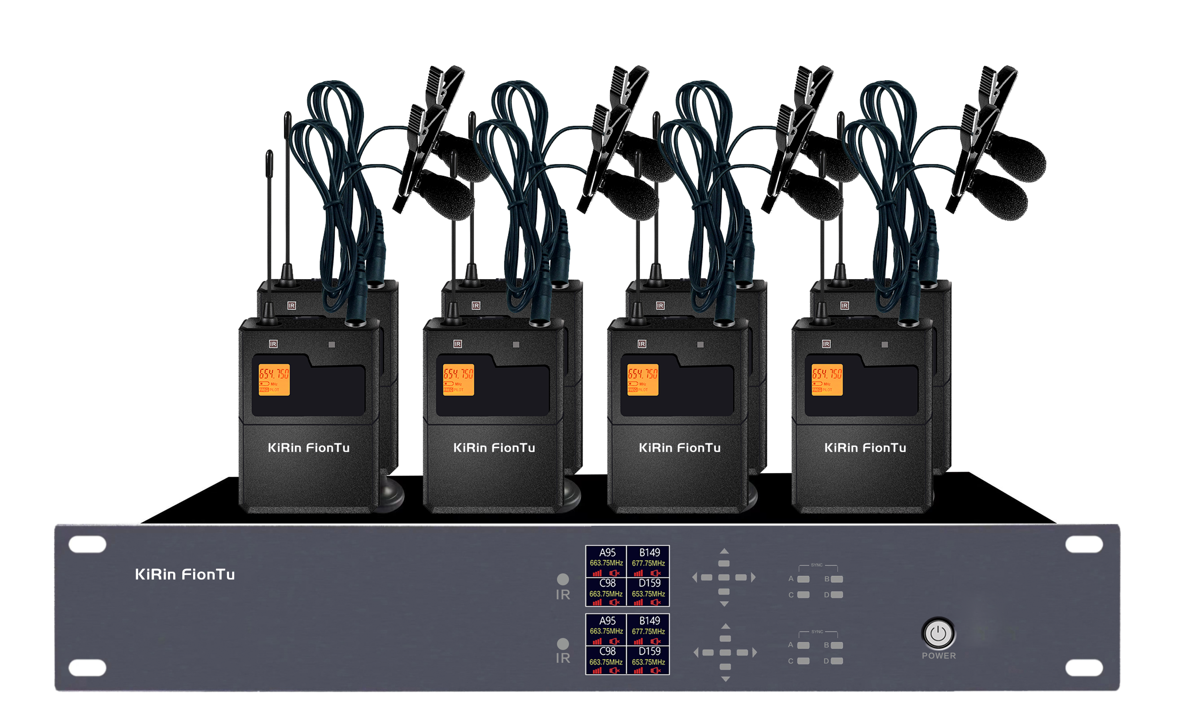

**Feature:**

**Specification:**

1. The receiver uses two 1.8-inch TFT color displays, which can display eight channels, battery power, frequency, volume, audio level, signal strength, speech status and other information at a glance

2. The receiver has a built-in button unlock/lock function, and the howling suppression function can be turned on or off as needed

3. The receiver has a built-in equalization function, which can choose direct, low-cut, high-cut, and user mode (13-band equalization. to adapt to more occasions

4. The receiver uses diversity reception technology, and the CPU automatically selects the optimal signal to ensure stable signal reception and prevent frequency interruption

5. The receiver has a built-in 4-group frequency grouping function, which effectively improves the installation efficiency of multiple sets used at the same time

|  |  |
| --- | --- |
| Receiver technical parameters |  |
| Working frequency | 640-690MHz |
| Channel | 8*25 channels adjustable |
| Comprehensive signal-to-noise ratio | >105dB |
| Comprehensive distortion | <0.5% |
| Frequency response | 50Hz-18KHz (±3dB) |
| Antenna | 1.2m magnetic antenna*8; BNC |
| Usage distance | up to 80 meters |
| Modulation mode | broadband FM |
| Frequency stability | ±0.001% |
| Dynamic range | >100dB |
| Sensitivity | -95dBm |
| Peak frequency deviation | ±45KHz |
| Output socket | 2-way MIX OUT6.35 mixed output, 8-way BAL OUT independent output, 2-way UNBAL OUT mixed output |
| Power supply | DC 12V 2A |
| Dimensions | width 480*depth 254*height 89mm (excluding antenna) |
| Transmitter |  |
| Spurious suppression | -60dB |
| Harmonic suppression | >55dBc |
| Power supply voltage | 1.5V AA battery*2 |