**FT_DS-G10 E-L-V2.0.2.231219**

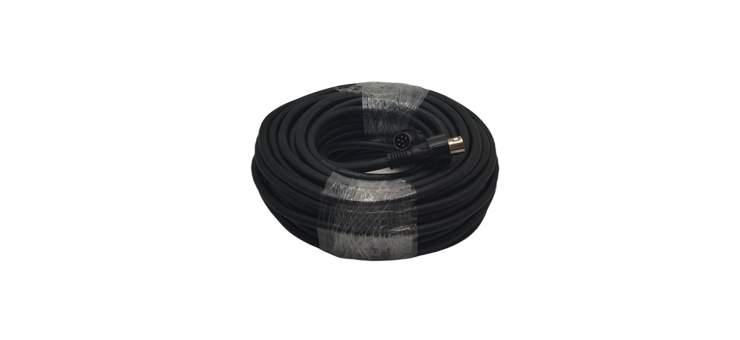

**Feature:**

1.20m conference system main cable, used to connect the conference system host and microphones

**Specification:**

|  |  |
| --- | --- |
| Diameter | 7.8mm |
| Wire Core | 6-core |
| Shielding | Wound wire + aluminum foil |
| Cable Length | 20m |